Alexey Leontyevich Byzov (1926-1998)

Alexei Leontyevich Byzov was born in Moscow on 2 January 1926. Byzov graduated from the Biological faculty of the Lomonosov Moscow State University (MSU) in 1950. He successfully defended his PhD thesis in 1956. Between years 1950 and 1957 he was working at the Institute of Evolutionary Morphology and Animal Ecology of the USSR Academy of Sciences (AS). Since 1957 Byzov had been working at the laboratory of visual perception of the Institute of Biophysics of the USSR AS that was started by N.D. Nyberg and M.M. Bongard in the 1950s. At that time in the laboratory worked eminent scientists in the field of visual physiology: the first head of the laboratory, mathematician Nikolay Nyberg (Nyberg, 1933) and physicist Mikhail Bongard (Bongard, 1955), experts in the field of colour vision, the virtuoso of scientific experiment Alfred Yarbus, who studied physiological properties of eye movements (Yarbus, 1967), the entomologist Masokhin-Porshnyakov, who investigated various aspects of insect vision (Masokhin-Porshnyakov, 1969) and physicist Mikhail Smirnov, who specialized in optics (Smirnov, 1971). Later on the laboratory was moved to the Institute for Information Transmission Problems of the USSR AS. Following the tragic passing of M.M. Bongard, A.L. Byzov became the head of the laboratory in 1971.
One of the key research programs of that time was the study of the retinal neurophysiology. “Retina is a part of the brain that is positioned at the periphery” – this anatomically correct thesis could be heard as a common motto from practically each and every scientist that took part in that international program. However the idea underlying it was that if one could decode the algorithms behind the neural functioning and interaction between the retinal neurons, it would bring us much closer to the understanding of the principles of brain functioning as a whole system. In the sixties of the last century A.L. Byzov has moved to systematically studying of the functional properties of various types of retinal neurons and obtained a series of original important results (see review of Byzov, 1971). In 1966 Byzov defended his doctorate thesis “An electrophysiological study of retina”. His monograph was published the same year under the same title (Byzov, 1966). In 1968 he received the I.M. Sechenov award for his electrophysiological studies of retina by the USSR AS presidium. Many of Byzov's colleagues agree on that he played a very important part in the development of neurophysiological research in the former Soviet Union. Both he and P.G. Kostyuk started to record intracellularly from single neurons nearly simultaneously. A.L. Byzov showed that despite the lack of decent technical equipment it is possible to obtain original and outstanding results. Alexey Leontyevich was an outstanding experimenter who made practically everything, starting from experimental setup to microelectrodes, with his own hands. The registration of the signals from isolated neurons with intracellular microelectrodes was developed as an electrophysiological practice due to a vacuum tube amplifier with high input resistance that was designed by A.L. Byzov together with M.M. Bongard and K.V. Golubtzov. A.L. Byzov also designed an original setup used to make glass micropipettes. For years Soviet electrophysiologists used microelectrodes that were made on the setup originally engineered by A.L. Byzov instead of the manufactured ones. The experimental box together with micromanipulator, microscope and photostimulation setup was hung on tight ropes on the

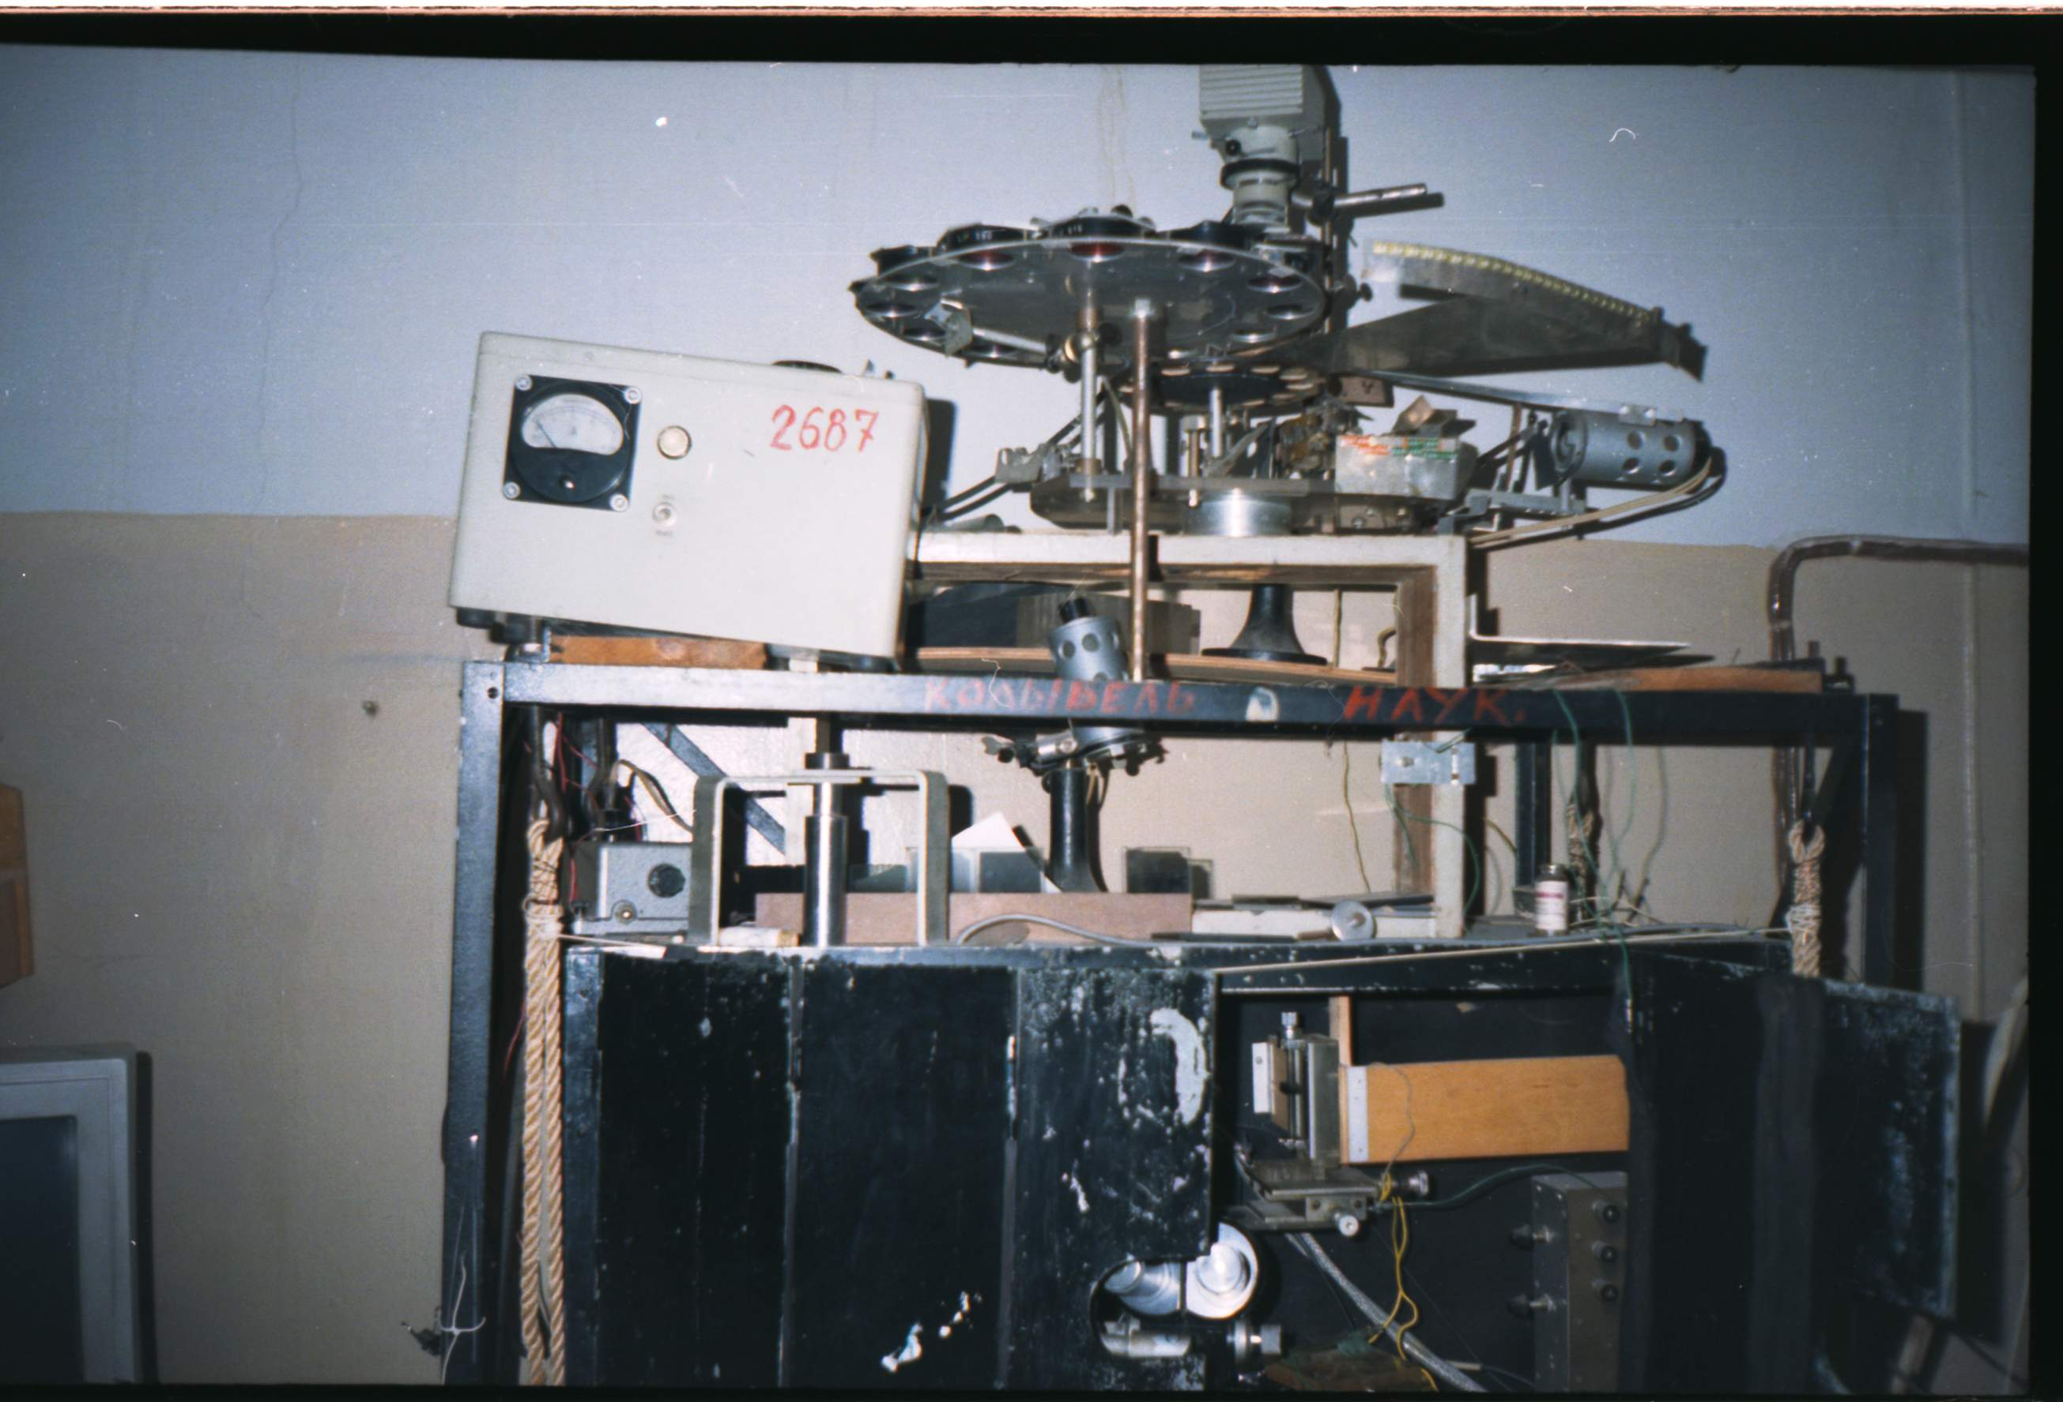

Fig. 1 “The cradle of science” - electrophysiological unit of Dr Byzov.

metallic construction. It was ironically named in the lab “the cradle of science” (Fig. 1). When any part of the setup would break in the course of an experiment, Byzov could immediately fix the problem without any hesitation as every single part of it was created with his own hands. He used to be a hardworking, venturesome and enthusiastic leader who would always generously share his experience with others. It would be no exaggeration to say that all of the Russian electrophysiologists as well as many of those working abroad on the intracellular electrophysiology are his direct students or have learned from the latter.

Main topics of Dr Byzov’s research

The main experimental research interests of A.L. Byzov were focused of the cellular mechanisms of visual information transmission and processing in retina. Together with Yu.A. Trifonov, his student and the closest co-worker, Byzov found some of the most significant features of the synaptic transmission from photoreceptors to the neurons of the secondary order (bipolar and horizontal cells). In these historical experiments original methodical approach developed by Trifonov and Byzov was applied. Electrical pulses of 1 msec duration were passed radially through the isolated retina from the photoreceptor side and evoked electrical responses of horizontal cells (HCs) were simultaneously recorded (Trifonov & Byzov, 1965). By using this method in experiments with the turtle retina, Trifonov unequivocally proved that the photoreceptors are depolarized and quite active in the dark, constantly releasing excitatory neurotransmitter, whereas the light hyperpolarizes them and blocks transmitter release. Later on A.L. Byzov has repeated the original experiment by Trifonov on the carp retina while working at the laboratory of the famous visual physiologist T. Tomita. Tomita was very impressed by the experiment and cited the papers of Trifonov and Byzov (Trifonov, 1968; Byzov & Trifonov, 1968) in his fundamental review “ Electrical activity of vertebrate photoreceptors” published in 1970 (Tomita, 1970).
A.L. Byzov together with Yu.A. Trifonov, K.V. Golubtzov, T. Shura-Bura, V.V. Maximov, E.M. Maximova, A.V. Minor., L.M. Chailahian gave considerable time and research effort to studying the physiological properties of the retinal HCs. In 1967, already Byzov showed that the electric polarization of horizontal cells in the turtle retina affects the magnitude of the light-induced local electroretinogram (ERG). The hyperpolarization increased the ERG, while depolarization decreased it. On this basis, Byzov formulated an idea of horizontal cells as regulators of synaptic transmission from receptors to subsequent neurons (Byzov, 1967). Later, Maximova showed that such a polarization of HCs in a similar way changes responses of the retinal outputs - the ganglion cells (Maximova, 1969). These early works testified that HCs which form electrical syncytia play an important role in the organization of the peripheral receptive fields of ganglion cells. It should be noted that electrically-coupled HC networks were thoroughly investigated and discussed in the number of papers published by colleagues of our laboratory (Minor & Maximov, 1969; Byzov, 1975; Byzov & Shura Bura, 1983). One of the most important finding of these studies was made in research on the turtle retina. Byzov and his coauthors as well as their colleagues from abroad showed that different parts of L-HCs – cell bodies and axon terminals are electrically isolated and form separate syncytial layers (Simon, 1973; Byzov, 1975; Byzov & Shura Bura, 1983; Lamb, 1976). Similar pattern was demonstrated in the fish retina (Teranishi, 1983).
Another important topic investigated by Byzov and coworkers were the nonlinear properties of the HC nonsynaptic membrane. The analysis of the model and of experimental data showed that the nonsynaptic membrane of HCs is able to amplify the graded potentials generated by subsynaptic membrane (Trifonov et al., 1974; Byzov et al., 1977b; Byzov & Trifonov, 1981). Byzov considered that this effect underlies the amplification of the fish L-HCs responses to blue stimuli when presented on the red background, previously found and studied in detail by Maximova and co-workers (Maximova et al., 1966). Similar effects in the fish retina were later on described by Naka and Rushton (Naka & Rushton, 1967).
In late seventies and eighties of the last century Byzov together with co-workers formulated principle of electric (ephaptic) feedback in triad synapses of the retinal outer synaptic layer (Byzov, 1977; Byzov et al., 1977a; Byzov & Shura Bura, 1986; Byzov & Polischuk, 1987). This theory assumes that cones release glutamate in a Ca2+-dependent manner, while HCs feed back to cones via extracellular current flow, generated by the HC membrane in response to chemical synaptic input from photoreceptors (“ephaptic mechanism”). It was proposed that ephaptic feedback is possible in invaginated con/HC synapses due to the high resistance of the extracellular synaptic space. During the last years of his life Dr Byzov together with the colleague of our laboratory Dr V.V. Maximov formulated the complex model of horizontal cell dynamics which comprised the dynamics of ephaptic feedback from HCs to cones (Maximov & Byzov, 1996; Byzov & Maximov, 1998). Furthermore, Byzov and Maximov together with L.L. Voronin and co-workers provided the evidence for ephaptic interactions in some invaginated synapses of hippocampal spiking neurons (Voronin et al., 1995; Kasyanov et al., 2000). It should be noted that during the lifetime of Dr Byzov his “electrical (ephaptical)” hypothesis was considered only as an alternative to the generally accepted “chemical” hypothesis implying that feedback transmission is mediated by GABA (see review of Piccolino, 1995). At the present time the ephaptic feedback is discussed as a fundamental feedback mechanism in cone/HC and other invaginated synapses of the central nervous system (see review of Vroman et al., 2013).
Despite the fact that for Byzov the functional organisation of the distal parts of retina was the main focus of his research, a number of his papers were on physiology and morphology of amacrine cells (Byzov & Utina, 1971). In addition to that together with G.M. Zenkin and N.A. Polishchuk he took part in a series of studies on lateral inhibition in the proximal part of the frog retina (Byzov et al., 1970; Polischuk & Zenkin, 1971).
A.L. Byzov gave special attention in his research to the light and dark adaptation both in the retina and the whole visual system (Byzov, 1969). Together with L.P. Kuznetsova A.L. Byzov performed a number of crucial studies on adaptation in the human visual system and the neuronal mechanisms of this phenomenon using the frog retina as a model system (Byzov & Kuznetsova, 1971).
While Byzov’s main research focus was the physiology of vision in vertebrates, he also was interested in studying the invertebrates’ vision as well. During the early sixties of the last century together with O. Yu. Orlov and I.A. Utina he performed detailed studies of cephalopod vision (Orlov & Byzov, 1961; Byzov & Orlov, 1962; Byzov et al., 1962). Colorimetric studies of squid and octopus retina gave strong evidence that these two cephalopod species are colour blind. Besides these researches Dr Byzov was also involved in studies of spider vision (Orlov & Byzov, 1962), while in the separate scientific project, together with S.Yu. Chaika and T.M. Vishnjevskaya, he actively worked on some aspects of insect vision (Chaika et al., 1997). It should be noted that Alexey Leontyevich also participated in various studies of other sensory systems. In particular, during the sixties of the last century together with A. V. Minor and G. I. Flerova he took part in the physiological studies of olfaction (Byzov & Flerova, 1964; Minor et al., 1969). Afterwards, in the eighties of the last century together with G. I. Rozhkova he initiated physiological studies of insect cercal system (Rozhkova & Byzov, 1985). Later on detailed studies on the subject were continued with the contribution of V. Yu. Vedenina (Vedenina & Byzov, 1990; Vedenina et al., 1992, 1993, 1998; Rozhkova et al., 1993). Besides that, Dr Byzov actively contacted and consulted colleagues working on the physiology of taste (A.I. Yesakov and co-workers) and electroreception (G. Broun and co-workers).
A.L. Byzov was a member of the International Marine Centre in Sardinia. He was an editorial board member of the international journal “Neuroscience” (Great Britain) as well as of some journals published by the Russian Academy of Sciences, such as “Sensorniye Systemy”, “Priroda”, “Uspehi Physiologicheskih Nauk”.
A.L. Byzov gave great importance to his work as a supernumerary referent at the Institute for Scientific and Technical Information (ISTI of the USSR AS) which played a prominent part in providing Soviet scientists with international research publications in the pre-Internet era. Byzov would encourage the laboratory staff members to participate in such work. Going through such enormous amounts of research publications, Byzov had always been on top of all the latest research results and did a great job as an editor for the papers written by his colleagues at the laboratory. A.L. Byzov read a special course on the “Physiology of the retina” at the Department of Physiology of the MSU that was a huge success among the students as well as given praise by the professorial staff.
During the last years of his life Alexey Leontyevich actively collaborated with colleagues from Serbia and Montenegro (Yugoslavia that time). According to the common scientific program with Institute for marine biology from Kotor (Montenegro) and Institute for multidisciplinary research from Belgrade (Serbia) colleagues of our laboratory planned to work on spectral properties of photoreceptors and HCs in fish inhabiting different photic environments (with the use of intracellular electrophysiological technics). The program was led and coordinated by A.L. Byzov, who also fulfilled the main experimental work. In the series of electrophysiological experiments together with I. Damjanović, Z. Gačić , B. Mićković and R.K. Andjus from Yugoslavia and E.M. Maximova and I.A. Utina from our lab spectral properties of eel retinal HCs were studied in detail (Byzov et al., 1998). In the research was used the same experimental procedure previously applied in analogous study of trichromatic retina of Siberian sturgeon Acipenser baeri Brandt (with V.I. Govardovskii and co-workers; Govardovskii et al., 1991). From measured spectral data of HCs it was concluded that eel is dichromat with two cone types having spectral maxima in the middle-wave and short-wave part of spectrum. The PhD thesis of I. Damjanović was based on these results and was successfully defended at the Biological Faculty of the University of Belgrade in 1996. Dr. Byzov took part in the defence as the main supervisor of the PhD project. Later on the results of our study were confirmed by means of microspectrophotometry with the contribution of J.K. Bowmaker and co-workers from University College London (Damjanović et al., 2005; Bowmaker et al., 2008).
Despite his long-term illness he continued to work until his last day. Apart from his extensive experimental work, during the last years of his life Alexey Leontyevich has given a lot of time to his duties as the head of the laboratory and carried out his organisational responsibilities as such. Moreover, he spent many hours working on theoretical publications together with V.V. Maximov (Maximov & Byzov, 1996; Byzov & Maximov, 1998), L.L. Voronin and colleagues (Voronin et al., 1995; Kasyanov et al., 2000) and D.S. Lebedev and V.I. Govardovskii (Lebedev et al., 1998). He also maintained close contacts with foreign colleagues. A dynamic and particularly productive collaboration took place at that time between Byzov and Dr M. Piccolino with co-workers from the University of Ferrara, Italy (Piccolino et al., 1996). Finally it should be said that A.L. Byzov put a lot of his efforts in organising the international conference on biophysics that took place in Kotor, Montenegro in 1998 with the support from the University of Belgrade. Unfortunately the conference had to be dedicated to the memory of A.L. Byzov as he had passed away on 20 July 1998.
A.L. Byzov had many hobbies. He enjoyed weaving baskets and furniture of vines, and making models of churches (Fig 2). He was an amateur photographer and musician, a culinary expert and liked to play table tennis as well. He had travelled thousands of kilometres around Russia, Europe and the United States being a fan of cycling (Fig 3).

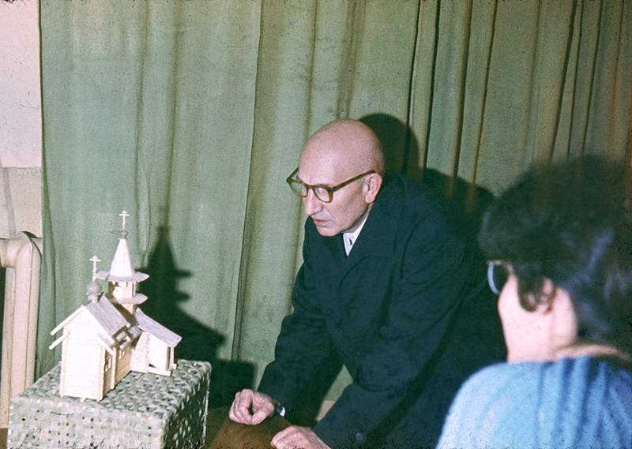

Fig. 2. A.L. Yarbus looks with interest at the model of church made by A.L. Byzov.

As a leader of the laboratory Byzov managed to continue its good traditions: democratic attitude, a broad array of research topics, the complex approach towards research problems and the encouragement of leadership qualities among the staff members. A.L. Byzov was an optimist and a true fighter both in his professional and everyday life.
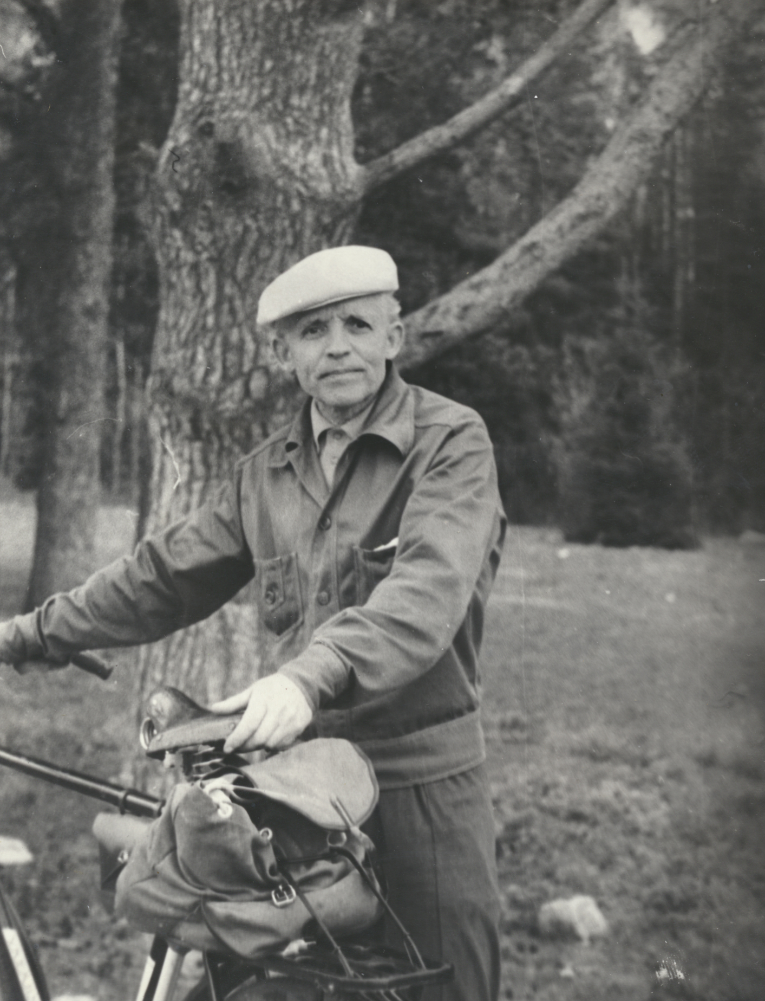

Fig.3. An optimist and a true fighter both in his professional and everyday life - A.L. Byzov with his dearest bicycle.

Literature – Byzov & coworkers
Byzov, A. L. (1966). Electrophysiological investigations of retina. Moscow: Nauka (in Russian).
Byzov, A.L. (1967) Horizontal cells of the retina as regulators of synaptic transmission. Sechenov Fiziologicheskiĭ Zhurnal USSR, 53, 1115-1124 (in Russian).

Byzov, A.L. (1969) Role of horizontal cells in retinal mechanisms of visual adaptation. Neirofiziologiya, 1, 210-218 (in Russian).
Byzov A.L. (1971) Neurophysiology of vertebrate retina. In: Physiology of Vision. Moscow: Nauka, 126-149 (in Russian).
Byzov, A. L. (1975) Interaction between horizontal cells of the turtle retina. Neirofiziologiya, 7, 279-286 (in Russian).
Byzov, A.L. (1977). Model of mechanism of feed-back between horizontal cells and photoreceptors in vertebrate retina. Neirofiziologiya, 9, 86-94 (in Russian).
Byzov A.L., Damjanoviċ I., Utina I.A., Miċkoviċ B., Gačiċ Z. & Andjus R.K. (1998). Electrophysiological and spectral properties of second-order retinal neurons in the eel. Comparative Biochemistry and Physiology, Part A, 121, 197-208.

Byzov, A.L. & Flerova, G. I. (1964) Electrophysiological research of the olfactory epithelium of the frog. Biofyzika, 9, 217-225 (in Russian).
Byzov, A.L., Golubtzov, K.V. & Trifonov, J.A. (1977a) The model of mechanism of feedback between horizontal cells and photoreceptors in vertebrate retina. In: Vertebrate Photoreception, Barlow H.B. and Fatt P. (eds). London: Academic Press, 265–274.
Byzov, A.L. & Kuznecova, L.P. (1971) On the mechanisms of visual adaptation. Vision Research, Suppl. 3, 51-63.

Byzov, A.L. & Maximov, V.V. (1998) Electrical feedback in chemical synapses. Russian J. Physiology, 84, 1074-1084 (in Russian).

Byzov A.L. & Orlov, O.Yu. (1962) Sources of cephalopod electroretinogram. Sechenov Fiziologicheskiĭ Zhurnal USSR, 48, 2-23 (in Russian).

Byzov A.L., Orlov, O.Yu. & Utina I.A. (1962) On the mechanisms of visual adaptation in the cephalopod eye. Biofizika, 7, 318-327 (in Russian).

Byzov, A. L. & Polischuk, N. A. (1987). On the mechanism of the feedback from horizontal cells to photoreceptors: Chemical or electrical hypothesis? Sensorniye Systemy, 1, 344-352 (in Rusian).
Byzov, A. L. , Polischuk, N. A. & Zenkin G.M. (1970) On the signal transduction in pulsed and non pulsed neural networks of retina. Neirofiziologiya, 2, 536-544 (in Russian).
Byzov, A. L. & Shura Bura, T. M. (1983). Spread of potentials along the network of horizontal cells in the retina of the turtle. Vision Research, 23, 389-397.
Byzov, A.L. & Shura-Bura, T.M. (1986). Electrical feedback mechanism in the processing of signals in the outer plexiform layer of the retina. Vision Research, 26, 33–44.

Byzov, A. L. & Trifonov, Y. A. (1968). The response to electrical stimulation of horizontal cells in the carp retina. Vision Research, 8, 817-822.

Byzov, A. L. & Trifonov, Yu. A. (1981) Ionic mechanisms underlying the nonlinearity of horizontal cell membrane. Vision Research, 21, 1573-1578.

Byzov, A.L., Trifonov, Yu.A., Chailahian, L.M. & Golubtzov K.V. (1977b) Amplification of graded potentials in horizontal cells of the retina. Vision Research, 17, 265-273.

Byzov A.L. & Utina I.A. (1971) The centrifugal effects on amacrine cells in the retina of frog. Neirofiziologiya, 3, 293-300 (in Russian).

Chaika S.Yu, Vishnevskaya T.M. & Byzov A.L. (1997) Ultrastructural organization of the basal part of retina in compound eye of grasshopper Tettigonia cantans. Moscow University biological sciences bulletin, 52, 39-44 (New York, N.Y., United States: Allerton Press).

Damjanoviċ I., Byzov A.L., Bowmaker J.K., Gačiċ Z., Utina I.A., Maximova E.M., Miċkoviċ B. & Andjus R.K. (2005). Photopic vision in eels – evidences of color discrimination. Annals of New York Academy of Sciences, 1048, 69-84.

Govardovskii V. I., Byzov A. L., Zueva L. V., Polisczuk N. A. & Baburina E .A. (1991) Spectral characteristics of photoreceptors and horizontal cells in the retina of the Siberian sturgeon Acipenser baeri Brandt. Vision Research, 31, 2047-2056.

Kasyanov A.M., Maximov V.V., Byzov A.L., Berretta N., Sokolov M.V., Gasparini S., Cherubini E., Reymann K. & Voronin L.L. (2000) Differences in amplitude-voltage relations between minimal and composite mossy fibre responses of rat CA3 hippocampal neurons support the existence of intrasynaptic ephaptic feedback in large synapses. Neuroscience, 101, 323-336.

Lebedev D.S., Byzov A.L., Govardovskii V.I. (1998) Photoreceptor coupling and boundary detection. Vision Research, 38, 3161-3169.

Maximov, V.V. & Byzov A.L. (1996) Horizontal cell dynamics: What are the main factors? Vision Research, 36, 4077-4087.

Minor, A. V., Flerova G. I. & Byzov A.L. (1969) Summarized evoked potentials and activity of single units in the olfactory bulb of frog. Neirofiziologiya, 1, 269-278 (in Russian).

Orlov, O.Yu. & Byzov A.L. (1961) Colorimetric study of cephalopod vision. Doklady Akademii Nauk USSR, 139, 723-725 (in Russian).

Orlov, O.Yu. & Byzov A.L. (1962) On the physiology of spider eye (Aranea). Biofizika, 7, 70-72 (in Russian).

Piccolino, M., Byzov, A.L., Kurennyi, D.E., Pignatelli, A., Sappia, F., Wilkinson, M. & Barnes, S. (1996) Low-calcium-induced enhancement of chemical synaptic transmission from photoreceptors to horizontal cells in the vertebrate retina. Proceedings of the National Academy of Sciences USA, 93, 2302-2306.

Rozhkova G.I. & Byzov A.L. (1985) Analysis of airstream direction in the insect cercal system. J. Evolutionary Biochemistry and Physiology, 21, 443-450.

Rozhkova G.I., Byzov A.L. & Vedenina V.Yu. (1993) Complex morphophysiological characteristics of giant cercal interneurons. In: Sensory Systems in Arthropods, Wiese K. et al. (eds.). Birkhauser Verlag, Basel, 403-409.

Trifonov Yu.A., Byzov A.L. & Chailahian L.M. (1974) Electrical properties of subsynaptic and nonsynaptic membranes of horizontal cells in the fish retina. Vision Research, 14, 229-241.

Trifonov, Y. A. & Byzov, A. L. (1965). The response of the cell generating S-potential on the current passed through the eyecup of the turtle. Biofizika, 10, 673-680 (in Russian).
Vedenina V.Yu. & Byzov A.L. (1990) Characteristics of sensory inputs in cricket cercal system. In: Sensory Systems and Communication in Arthropods, Gribakin F.G., et al. (eds.). Birkhauser Verlag, Basel, 371-376.

Vedenina V.Yu., Byzov А.L. & Rozhkova G.I. (1992) Medial giant interneuron in cricket: directional sensitivity and receptor inputs. Sensorniye Systemy, 6, 18-22 (in Russian).
Vedenina V.Yu., Rozhkova G.I. & Byzov A.L. (1993) Medial giant interneuron of the cricket nerve cord: directional sensitivity in adults and nymphs. In: Sensory Systems in Arthropods, Wiese et al. (eds.). Birkhauser Verlag, Basel, 410-416.
Vedenina V.Yu., Rozhkova G.I., Panjutin A.K., Byzov A.L. & Kaemper G. (1998) Frequency-intensity characteristics of cricket cercal interneurons: low-frequency-sensitive units. J. Comparative Physiology, 183, 553-561.

Voronin L.L., Byzov A.L., Kleschevnikov A.M., Kozhemyakin M., Kuhnt U. & Volgushev M. (1995) Neurophysiological analysis of long-term potentiation in mammalian brain. Behavioural Brain Research, 66, 45-52

Other cited literature

Bongard, M.M. (1955) Colorimetric studies on animals. Doklady Akademii Nauk USSR, 103, 239–242 (in Russian).
Bowmaker, J.K., Semo, M., Hunt, D.M. & Jeffery, G. (2008) Eel visual pigments revisited: The fate of retinal cones during metamorphosis. Visual Neuroscience, 25, 249-255.

Lamb, T.D. (1976) Spatial properties of horizontal cell responses in the turtle retina. J. Physiology, 263, 239-255.

Maximova, E.M. (1969) Effect of intracellular polarization of horizontal cells on the activity of the ganglion cells in the fish retina. Biofizika, 14, 537-544 (in Russian).

Maximova E.M., Maximov V.V. & Orlov O.Yu. (1966) The reinforcement interaction between signals from receptors in the cells - sources of S-potential. Biofizika, 11, 472-477 (in Russian).

Mazokhin–Porshnyakov, G.A. (1969) Insect Vision. New York: Plenum press.

Minor, A.V. & Maximov, V.V. (1969) Passive electrical properties of the flat cell model. Biofizika, 14, 328-335 (in Russian).

Naka, K.I. & Rushton, W.A.H. (1967) The generation and spread of S-potentials in fish (Cyprinidae), J. Physiology (London), 192, 473-461.

Nyberg, N.D. (1933) Mathematical ground for rendering colour body. An appendix to Fedorov N.T. Modern colorimetry. Moscow–Leningrad: Gostech.–Theor. Izdat. (In Russian).
Piccolino M. (1995) Cross-talk between cones and horizontal cells through the feedback circuit. In: Neurobiology and Clinical Aspects of the Outer Retina. Djamgoz M.B.A., Archer S.N. and Vallerga S. (eds). Chapman & Hall, London, 221-248.

Polischuk, N. A. & Zenkin, G.M. (1981) Two modes of lateral inhibition in the frog retina. Neirofiziologiya, 13, 549-555 (in Russian).

Simon, E. J. (1973). Two types of luminosity horizontal cells in the retina of the turtle. Ibid., 230, 199-211.
Smirnov, M.S. (1971) Eye optics. In: A handbook on physiology. Physiology of vision. Leningrad: Nauka. pp. 37–59 (In Russian).
Trifonov, Y. A. (1968). Study of synaptic transmission between the photoreceptor and the horizontal cell using electrical stimulation of the retina. Biofizika, 13, 809-817 (in Russian).
Vroman, R., Klaasen, L.J. & Kamermans, M. (2013) Ephaptic communication in the vertebrate retina. Frontiers in Human Neuroscience, 7, 1-4.
Yarbus, A.L. (1967) Eye Movements and Vision. New York: Plenum press.

Platon Grigoryevich Kostyuk, outstanding Soviet and Ukrainian neurophysiologist. From 1966-2010 director of Bogomoletz Institute of Physiology of Academy of Sciences of Ukrainian SSR (today National Academy of Science of Ukraine ).

